**Assignment 8.1(Hive Basics)**

**---------------------------------------**

**Task 1 :**

**-----------**

Create a database named 'custom'.

Create a table named temperature_data inside custom having below fields:

1. date (mm-dd-yyyy) format

2. zip code

3. temperature

The table will be loaded from comma-delimited file.

Load the dataset.txt (which is ',' delimited) in the table.

**Query for table creation:**

**----------------------------------**

create table temperature_data(dat String, zip Int,temp Int) row format delimited fields terminated by ',';

**Query for loading data into the table:**

**----------------------------------------------------**

LOAD DATA LOCAL INPATH '/home/acadgild/dataset_Session 14.txt into table temperature_data;

**Output Screenshot:**

**---------------------------**

Table created containing the loaded data:

--------------------------------------------------------------

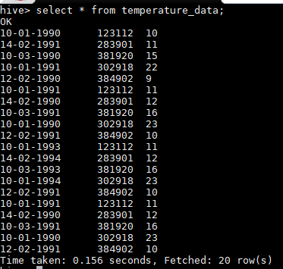

**Task 2**

**-----------**

1. Fetch date and temp from temperature_data where zip code is greater than

300000 and less than 399999.

**Query for the above task:**

**---------------------------------------**

select dat, temperature from temperature_data where zip > 300000 and zip < 399999.

**Output:**

**-----------**

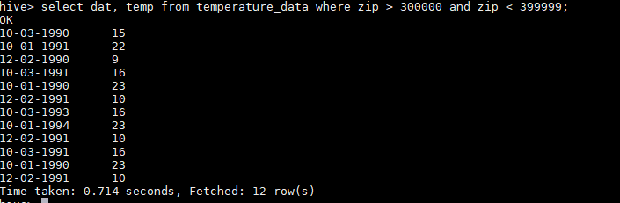

2. Calculate maximum temperature corresponding to every year from temperature_data

table.

**Query for the above task:**

**--------------------------------------**

select SUBSTRING(dat ,7,4) as year, MAX(temp) as temperature

from temperature_data

GROUP BY SUBSTRING(dat,7,4);

**Output:**

**-----------**

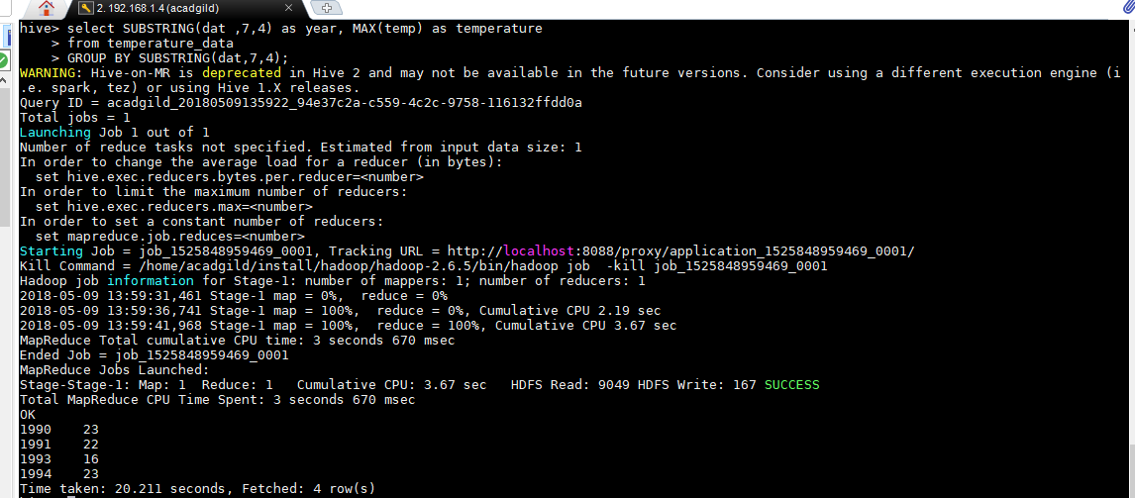

3. Calculate maximum temperature from temperature_data table corresponding to those

years which have at least 2 entries in the table.

**Query for the above task:**

**--------------------------------------**

SELECT dat, MAX(t1.temp) as temperature FROM

(select SUBSTRING(dat,7,4) dat, temp from temperature_data) t1 GROUP BY dat HAVING count(t1.dat) > 2;

**Output:**

**-----------**

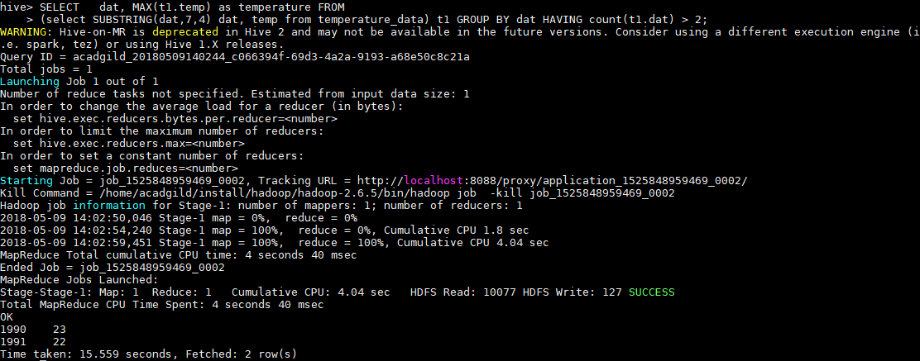

3. Create a view on the top of last query, name it temperature_data_vw.

**Query for the above task:**

**--------------------------------------**

create view temperature_data_vw as SELECT dat,

MAX(t1.temp) as temperature FROM

(select SUBSTRING(dat,7,4) dat, temp from temperature_data) t1 GROUP BY dat HAVING count(t1.dat) > 2;

**Output:**

**-----------**

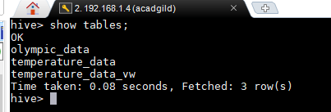

4. Export contents from temperature_data_vw to a file in local file system, such that each

file is '|' delimited

**Query for the above task:**

**--------------------------------------**

INSERT OVERWRITE LOCAL DIRECTORY '/home/acadgild/temperature_output' ROW FORMAT DELIMITED FIELDS TERMINATED BY '|'

**Output:**

**-----------**

